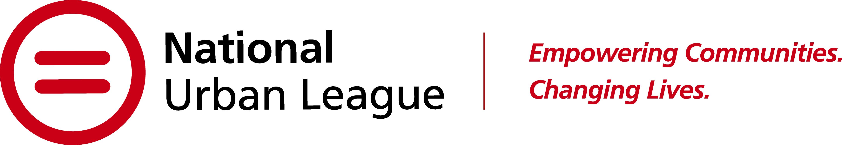

NATIONAL URBAN LEAGUE SUMMER INTERNSHIP PROGRAM

Summary:

Do you want real-world experiences?
Do you enjoy giving back to the community?
Would you enjoy behind-the-scenes work at a national conference?

Then you need to apply to the National Urban League Summer Internship Program!

The National Urban League Summer Internship Program provides an insight into the world of non-profit management for college students. The internship will be based in the headquarters office in New York City and Washington DC. The National Urban League is looking for candidates interested in a career in the not-for-profit sector, or in understanding the connection between non-profits, corporations, and government in the work of our nation. This internship is open to undergrads only. This internship will be a hybrid. 3 days in the office 2 days working from home.

This is a nine-week paid program (June 6 – August 3). We are interested in students from a variety of academic backgrounds and majors who:

- Have demonstrated academic achievement.
- Have strong interpersonal and communication skills.
- Are enthusiastic and eager to learn about the National Urban League.
- Are involved in extracurricular and community-related activities.

Why Participate?

The National Urban League offers valuable work experience in a professional, fast-paced environment. Some highlights of this summer’s activities include:

- Behind the Business Tours with corporate partners in the tri-state area
- Special assignments at the National Urban League Annual Conference in Houston Texas
- Exclusive meeting with President & CEO, National Urban League
- Work on The President’s Project - a special assignment from the President and CEO presented to Senior Leadership of the National Urban League at the end of the program
- Lunch with National Urban League’s “Women of Influence”
- Lunch with National Urban League’s “Men of Influence”
- Coffee Chats – Meet & Greet with professional staff

Requirements:

- Official current academic transcript (minimum 2.8 GPA)
- Resume
- One academic letter of recommendation
- One-page essay expressing interest in the program

To Apply:

Click the link: https://bit.ly/2023NULSummerInternship to apply online & upload all your required documents

Deadline: February 17, 2023

WE ARE AN EQUAL OPPORTUNITY EMPLOYER The National Urban League is an Equal Opportunity Employer and is committed to complying with all federal, state, and local equal employment opportunity (“EEO”) laws. The National Urban League strictly prohibits discrimination against any employee or applicant for employment because of the individual's race, color, sex (including pregnancy), religion or creed, national origin, alienage, citizenship, age, sexual orientation, disability, gender identity or expression, sexual and reproductive health decisions or decision making (of employees or their dependents), familial status, marital status, partnership status, genetic predisposition or carrier status, military status, domestic violence victim status, arrest or pre- employment criminal conviction record, or any other characteristic protected by law. This policy applies to all National Urban League activities, including, but not limited to, recruitment, hiring, compensation, assignment, training, promotion, discipline, and discharge. This policy also bans discriminatory harassment. Employment at the National Urban League is at will.

